**Water Front Pavilion**

Jersey City, New Jersey

**Architect**  Adamson Associates Architects (AAA)

**Partner-in-Charge** Michael Poitras (AAA)

**Project Manager** Raminder Kanetkar

**Year work completed** 2004-2005

**Project Value** $1, 500,000

**Project Description:**

**Gross Floor Area: approx. 3, 000sqft on 1 floor**

A small Ticket Booth and Ferry Terminal located on Hudson River in a prestigious office area in New Jersey, to provide Ferry connection to the New York City, was a unique project that was rigorously detailed and built with high end expensive materials. For example the Green marble was imported from Italy for the exterior pavilion wall. The building was built on pile footings, walkways and decks had a flexible base that provided movement with the flowing & rising water. Exterior facade was built of stone cladding on fully grouted concrete block wall backing. Due to water pressure, wave action and the presence of corrosive salts in the Hudson river, the building construction and materials had to be of superior quality. Interior spaces were kept simple and were finished with low maintenance sustainable materials such as exposed concrete for floors, stainless steel base and certified woods for counters areas.

**Unique Design Features:**

Some of the project's unique design features included:

-A low slope zinc standing seam roof provided resistance from corrosive environment and provided a handsome roof visible from high rise surrounding towers.

-A modular system of construction where all joints and details from stone wall to roof soffits & interior finish materials were co-ordinated

and detailed rigorously.

-clerestory operable windows in the glazed facade provided natural ventilation in summer and were a prime source of cooling as the building was not air conditioned. Building was kept warm with radiant heating from heated concrete floors in winter.

**Challenges Unique to the Project:**

Goldman Sachs & Hines as a client had very high expectations from the design team. Adamson in joint venture with Caesar Pelli Architects worked as a team to deliver a very well detailed, simple yet elegant structure.

**Project Involvement/Role:**

As a Job Captain working directly with the project principal, the responsibilities on this project included:

-exterior landscape details,

-exterior facade and soffit details,

-Interior space design and details,

-production and co-ordination of Tender and Construction documents,

-Review of shop drawings.

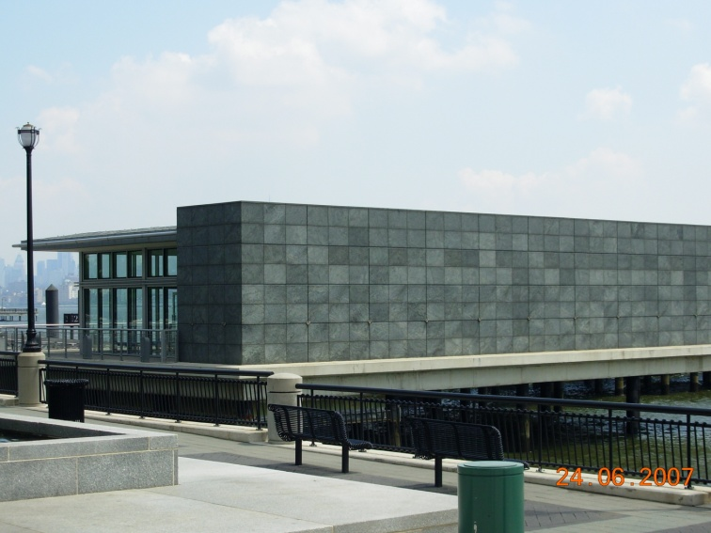 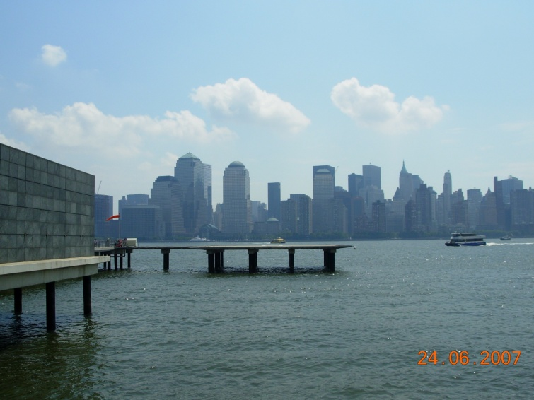

**Side View View of New York skyline from Pavilion**

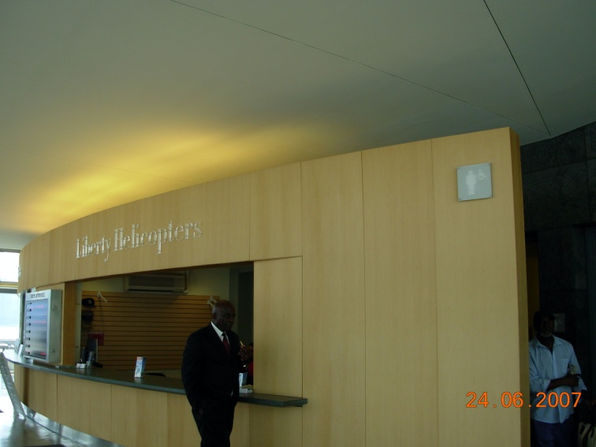 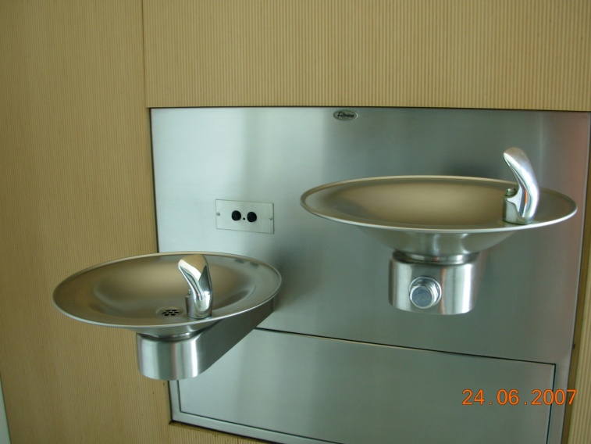

**Ticket Counter Details-Drinking Fountain**

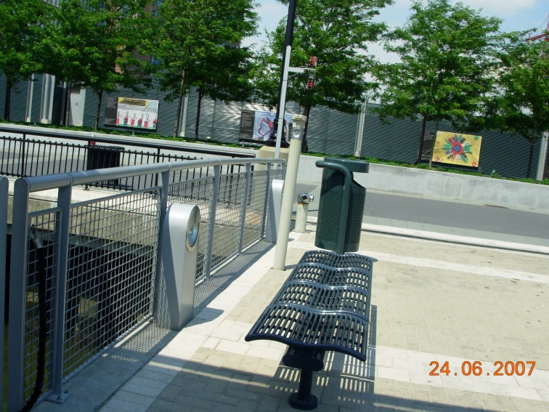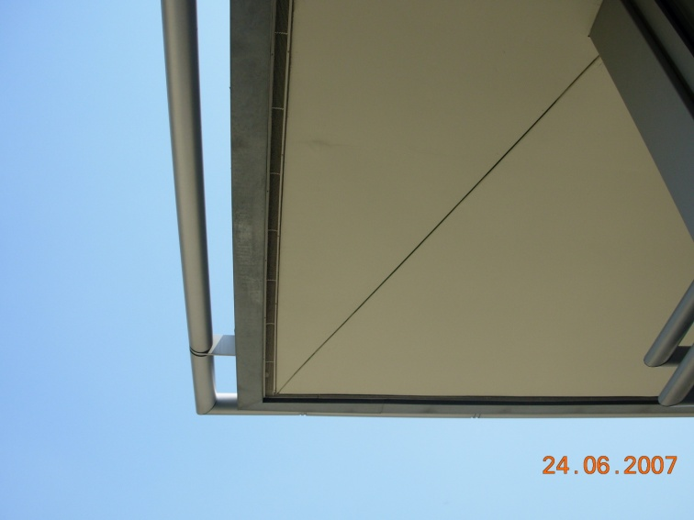  
**Details-Exterior Railing Details-Soffit**